**BRAC UNIVERSITY**

B

**Department of Computer Science and Engineering**

**CSE420: Compiler Design**

**Quiz 01, Summer 2016**

**Duration: 1.00 hours, Total Marks: 30**

**Student Name:**

**Student ID:**

**Section:**

1. Mention some other applications of compiler design techniques. [2]
2. What factors have influenced the functional division of Lexical and Syntax Analyzer? [2]
3. State the basic differences between NFA and DFA. [2]
4. Convert RE (**a*b)|(bca)|(c|a)\*** to NFA using Thompson’s Construction. [6]
5. Convert following NFA to DFA using Subset Construction method. [3]

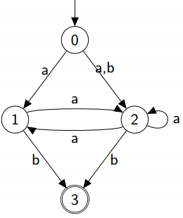

5. Convert following DFA to RE : [4]

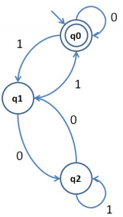

6. Draw the syntax tree of RE **(x.y.z).(m+n*+o)\*** and determine the first-pos, last-pos, follow-pos of each node. [2+1.5+1.5+3]

7. Remove ambiguities from the following grammar: [3]

 S-> SS+

 S-> SS*

 S-> a